Supplemental Material to

Retention Database for Prediction, Simulation and Optimization of GC Separations

Tillman Brehmer1,*, Benny Duong1, Manuela Marquart1, Luise Friedemann1,2, Peter J. Faust1,3, Peter Boeker1,3, Matthias Wüst1, Jan Leppert1

1 University of Bonn, Institute of Nutritional and Food Sciences, Chair of Food Chemistry - Department Fast GC, Endenicher Allee 11 - 13, 53115 Bonn, Germany

2 Hochschule Bonn-Rhein-Sieg, Department for Applied Sciences, Von-Liebig-Straße 20, 53359, Rheinbach, Germany

3 HyperChrom GmbH Germany, Endenicher Allee 11 -13, 53115, Bonn, Germany

Corresponding author: Tillman Brehmer, brehmer@uni-bonn.de

# Introduction:

The supporting informations includes the following files:

## CSV Files:

* Database_measurements.csv: Database including only the data of our own measurements.
* Database_all.csv: Database including all data from the literature and measurements
* Dabase_verficated.csv: Database including only data that pass the verification process.

## HTML-Files:

You can watch the HTML files easily in your Browser.

* Notebook_PCA.html: Static Pluto Notebook, including the Database, some 3D plots of the data and processing steps of the PCA analysis. Use the Table of Content menu on the right hand side to navigate through the document.
* Figure S2.html: 3D plot of the ABC parameters compound category
* Figure S2.html: 3D plot of the K-centric parameters sorted by compound category
* Figure S4.html: Chromatogram of the measurement and simulation of FAMEs with focus on the simulation of unsaturated FAMES such as C18:1, C18:2, C18:3 and C20 derivates.

# Lambert $W$ function

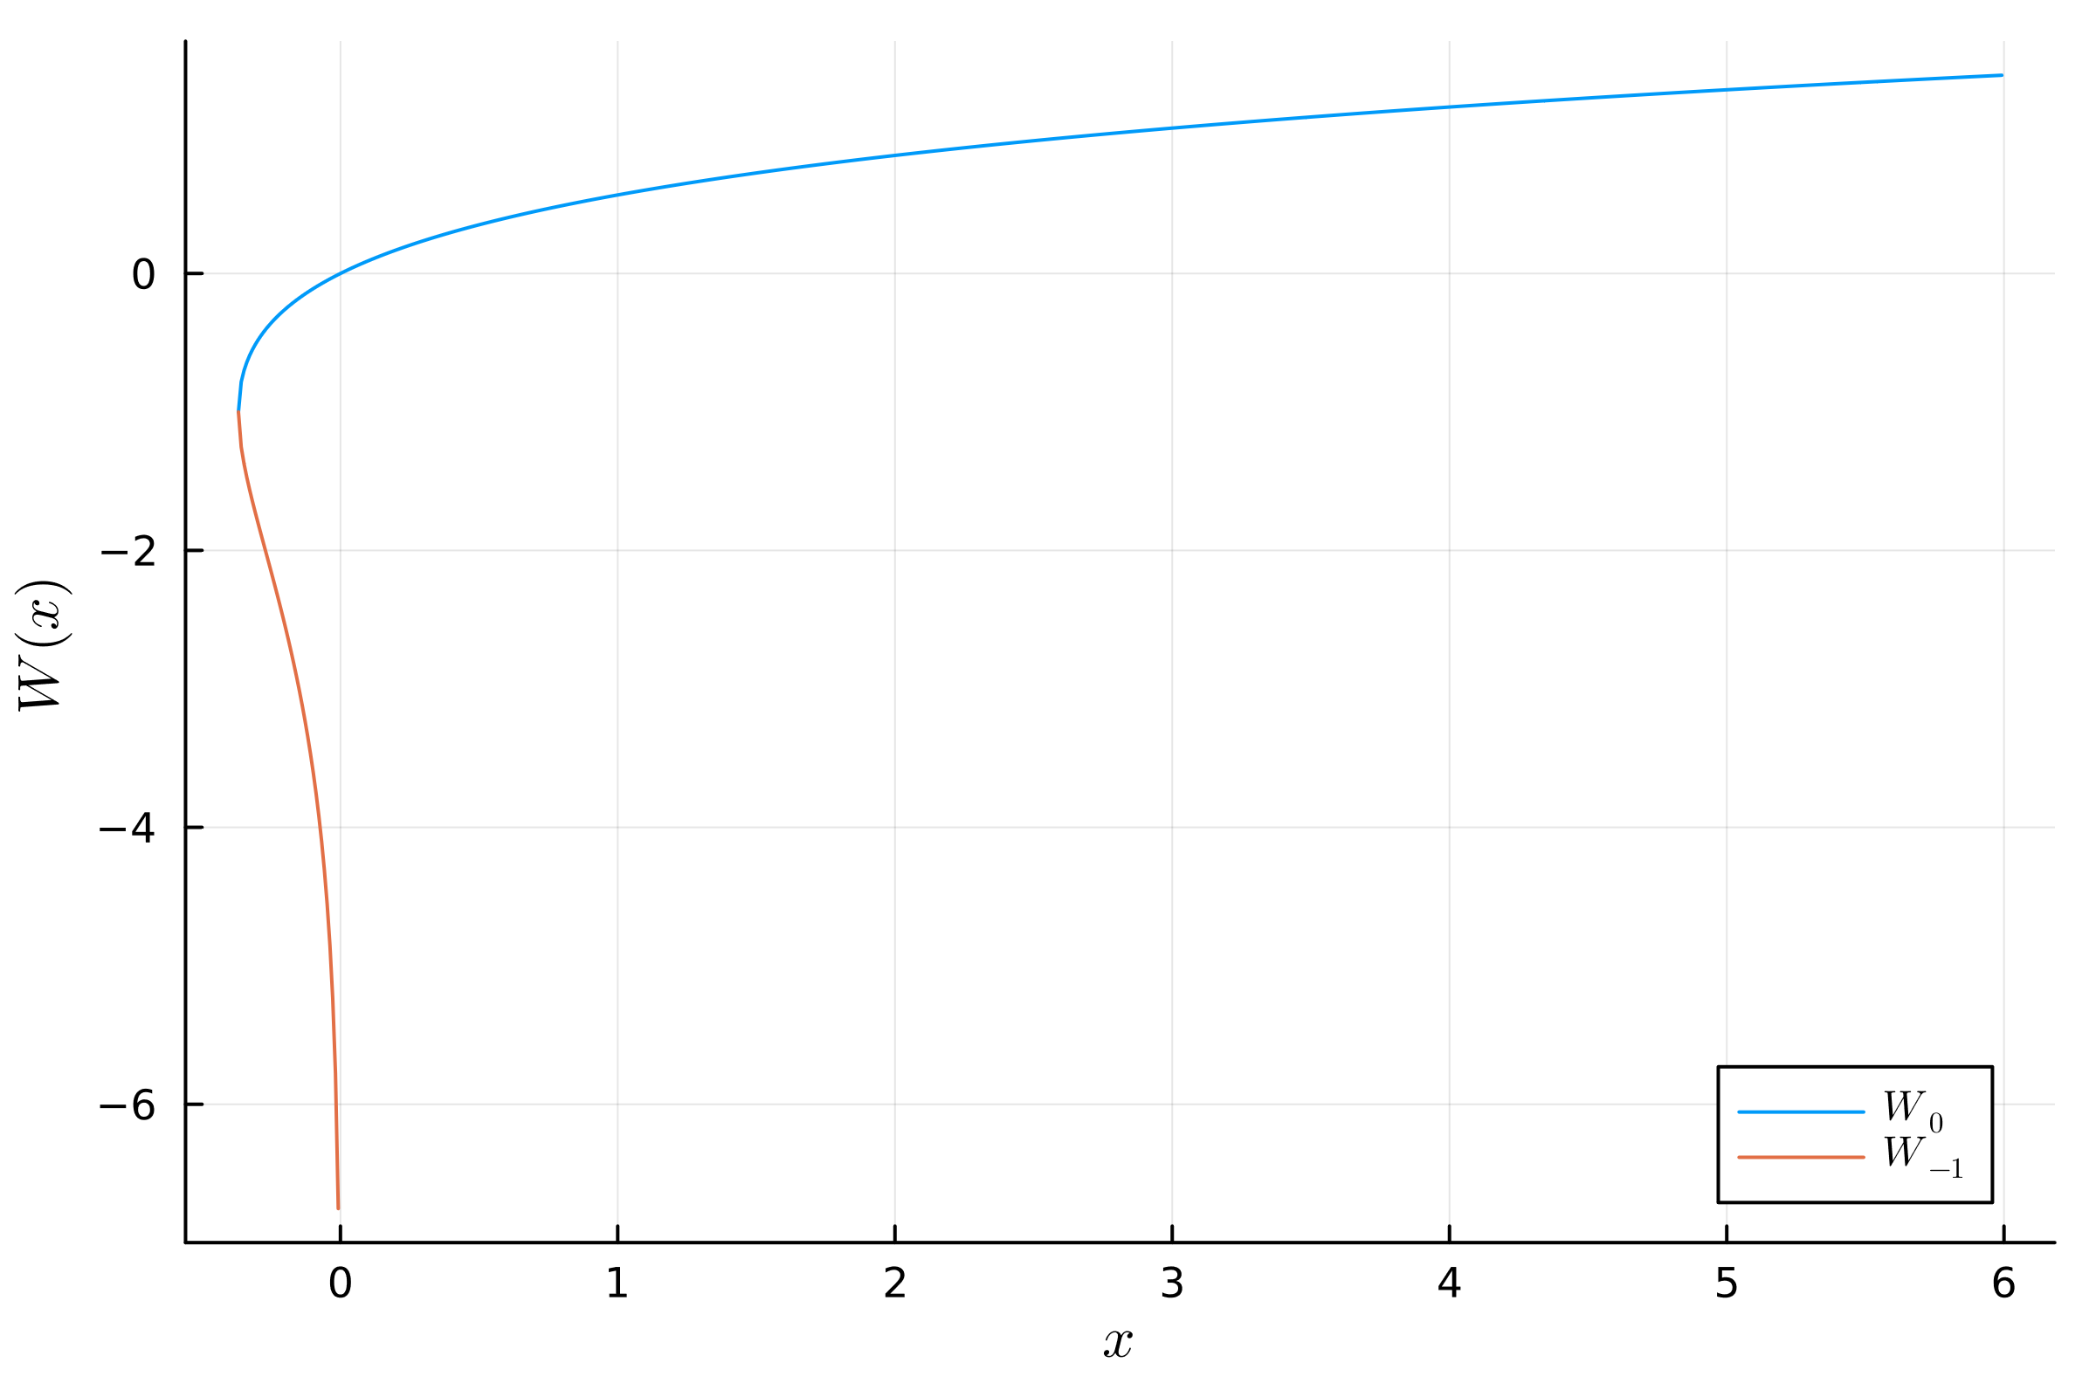

Figure S1 Plot of the Lambert $W$ function with its to branches $W_{0}$ and $W_{-1}$.

# Results of PCA for ABC parameters

PCA(indim = 3, outdim = 1, principalratio = 0.9999869043312775)

Pattern matrix (unstandardized loadings):

|  |  |
| --- | --- |
|  | PC1 |
| 1 | -44.6158 |
| 2 | 5030.39 |
| 3 | 5.82951 |

Importance of components:

|  |  |
| --- | --- |
|  | PC1 |
| SS Loadings (Eigenvalues) | 2.53069e7 |
| Variance explained | 0.999987 |
| Cumulative variance | 0.999987 |
| Proportion explained | 1.0 |
| Cumulative proportion | 1.0 |

# Results of PCA for $K$-centric parameters

PCA(indim = 3, outdim = 2, principalratio = 0.9989824070935823)

Pattern matrix (unstandardized loadings):

|  |  |  |
| --- | --- | --- |
|  | PC1 | PC2 |
| 1 | 77.7062 | -18.3845 |
| 2 | 4.50909 | 0.237877 |
| 3 | 36.2117 | 39.4215 |

Importance of components:

|  |  |  |
| --- | --- | --- |
|  | PC1 | PC2 |
| SS Loadings (Eigenvalues) | 7369.88 | 1892.11 |
| Variance explained | 0.794903 | 0.204079 |
| Cumulative variance | 0.794903 | 0.998982 |
| Proportion explained | 0.795713 | 0.204287 |
| Cumulative proportion | 0.795713 | 1.0 |